Mark Caprara, Ph.D.
Center for Scientific Review, the National Institutes of Health
Short Bio: Dr. Caprara is a Scientific Review Officer at the Center for Scientific Review. He oversees the review of applications for the NIH Common Fund and Big Data to Knowledge Initiatives. Most of the review meetings he leads focuses on computational and statistical methods for the acquisition, management, querying, sharing and analysis of biological and clinical data. Prior to joining NIH he was a faculty member at Case Western Reserve University Medical School conducting research on RNA processing and mobile genetic elements.

Valerie Florance, Ph.D.
Director, NLM Extramural Programs, Heads NLM’s Extramural Programs Division, which is responsible for the Library’s grant programs. Coordinator for NLM informatics training programs.
Valerie Florance, Ph.D., is an Associate Director of the National Library of Medicine, NIH. There, she directs NLM’s Extramural Programs Division, with overall responsibility for research, training and resource grant programs in biomedical informatics and health information sciences. She serves as program director for NLM’s highly-regarded university-based training programs in biomedical informatics. Dr. Florance is a member of the Executive Committee for the NIH Big Data to Knowledge (BD2K) initiative. Before coming to NLM in February 2001, she spent 3 years leading a visioning project undertaken at the Association of American Medical Colleges (AAMC) to help the association’s members understand the power of computers and networks for managing health information. Before that, she held faculty and administrative positions at three U.S. academic medical centers. She has graduate degrees in medical anthropology and biomedical information sciences, and was elected to the American College of Medical Informatics in 2005.

Dan Gallahan, Ph.D.
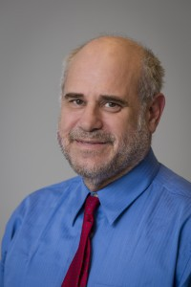
Deputy Division Director, Division of Cancer Biology, NCI
Dan Gallahan is Deputy Director of the Division of Cancer Biology at the National Cancer Institute (NCI) and helps lead the Division in its mission of supporting and facilitating basic cancer biology research. His primary focus at NCI is the application of integrated approaches, tools, and data sets to understanding cancer. He established and still oversees the Division’s efforts in cancer systems biology, the latest of which is the Cancer Systems Biology Consortium (CSBC). As Deputy Director, he also assists in planning and implementing the NCI’s overall efforts in genomics, proteomics, structural biology, and nanotechnology, and is a liaison with other government and commercial entities in the areas of technology and systems biology. Dr. Gallahan is a molecular and cancer biologist with broad expertise in the fields of systems biology, breast cancer, technology development, and science policy. He was trained in Molecular Biology and Biochemistry at the University of Maryland, with additional post-doctoral training at the NIH and the German Cancer Research Center. His post-doctoral work included training in cancer biology, proteomics, and bioinformatics. Prior to joining the Division of Cancer Biology, he had an active NCI intramural career in the Laboratory of Tumor Immunology and Biology.

Wendy Nilsen, Ph.D.
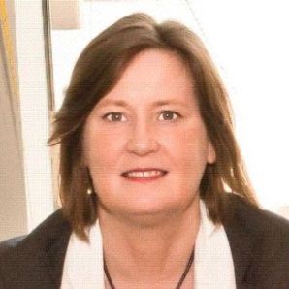
Program Director, National Science Foundation
Wendy Nilsen, Ph.D. is a Program Director for the Smart and Connected Health Program in the Directorate for Computer & Information Science & Engineering at the National Science Foundation. Her work focuses on the intersection of technology and health. This includes a wide range of methods for data collection, data analytics and turning data to knowledge. Her interests span the areas of sensing, analytics, cyber-physical systems, information systems, big data and robotics, as they relate to health. More specifically, her efforts include: serving as cochair of the Health Information Technology Research and Development community of practice of the Networking and Information Technology Research and Development Program; the lead for the NSF/NIH Smart and Connected Health announcement; convening workshops to address methodology in mobile technology research; serving on numerous federal technology initiatives; and, leading training institutes. Previously, Wendy was at the NIH Office of Behavioral and Social Sciences Research (OBSSR).

