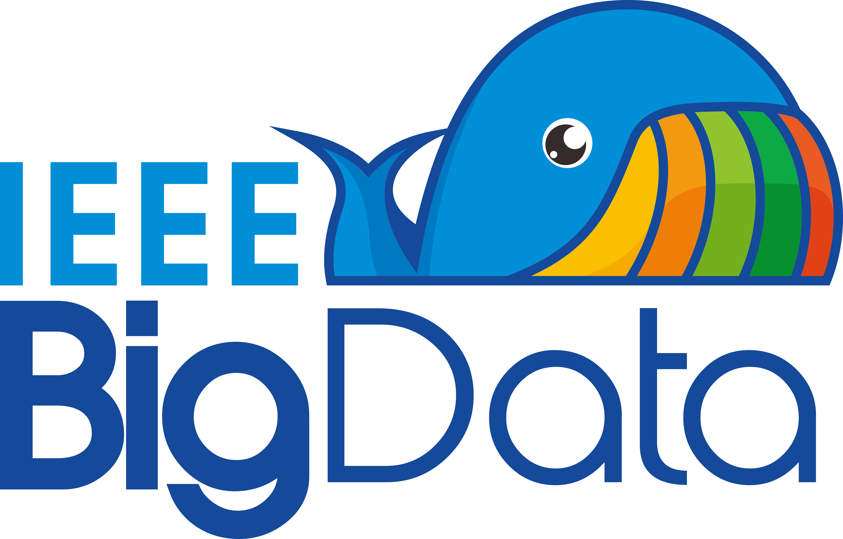
IEEE BHI 2017 Big Data
Analytics and Visualization Competition
Call for Participants

Data Science is all about the processes and methods to access and analyze data to gain insights for informed decision making. To promote the awareness and analytic technology of Big Data, IEEE EMBS and the IEEE Big Data Initiative are organizing a Data Analytics Competition. The competition will be held during IEEE BHI2017 and is open to all participants of the conference.

Data
Data is all around us and everywhere. In particular, biomedical data is relevant to the themes of the 4th International Conference on Biomedical and Health Informatics (BHI2017). The challenge is to analyze a curated dataset and determine what can be learned from the data.

Check out the following data repository site, https://ieee-dataport.org/competitions/bhi-2017-big-data-analytics-competition, which contains a curated dataset of US patent information based upon BHI keywords. Your challenge is to determine the value from the data and find something interesting to conduct your analytics.

Questions
One consideration for example, better informed practitioners, clinicians, consumers will enable stronger patient care and health management. A study of the data may provide potential predictive trends and recommendations for a better informed consumer. What insights can you provide by analyzing the dataset? Your insights and suggestions are expected to be creative. Based on this dataset, what are the most common medical and health applications where patent development is occurring? How frequently are patents being filed with the same title? How would you improve this dataset to better distinguish unique patents with duplicate titles? What additional data / metadata would you include in this dataset to help researchers more efficiently locate relevant medical and health patents? What conclusions can you draw from this data? What trends, if any, have formed over the past decade? Where are the trends moving? Consider both health industry and patent filing perspectives. What anomalies can you find in this data? Is there anything that affects the integrity of the data?

Participation
Participation is open to conference attendees only. To participate, please send an email to Kathy Grise (k.l.grise@ieee.org) and Theresa Cavrak (t.cavrak@ieee.org). You may participate individually or as part of a team.

Evaluation and Awards
You are expected to present your findings to a panel of judges. Presentations will be evaluated based on the following criteria:

- Selection criteria of the dataset
- Clarity and Relevance of Analysis
- Methodology
- Creative use of data
- Significance of findings and recommendations
- Delivery of findings and recommendations

Two awards will be given out, 1) winning student or student team; 2) winning professional or professional team. A judging panel of practitioners will evaluate presentations and each winning team (or individual) will be awarded with $1,000.

The presentations should be formatted as a PowerPoint document. Please be prepared to discuss your presentation for roughly 8-10 minutes.

Timeline
- Wednesday, 15th February 2017 – Final date for presentation submission
- Friday – Saturday, 17-18 February 2017 - Presentations
- Saturday, 18 February 2017 – Awards

PAIR Bulk Data. United States Patent and Trademark Office, pairbulkdata.uspto.gov. Accessed 10 October 2016. Keywords: Smart medicine, precision medicine, preventive medicine, bioinformatics, digital imaging, artificial intelligence, internet of things, mobile health, electronic health, telemedicine Status: Patented Case

